Two-Voice Poems

Two-Voice Poems are written from two different points of view on the same topic, concept, focus, etc…

1. Choose two people, families, groups, concepts or objects that have something in common.
2. Brainstorm some similarities and differences between these things. Use a Venn diagram or a T-chart to organize your ideas.
3. Some writers prefer to write one side’s point of view first. Others prefer to write them as a statement/answer, back-and-forth.
4. This poem is designed to be read by two voices. Set up the poem so that most of the time one voice is speaking at a time. At times, both voices may be speaking at the same time. See the model on the back for a sample of how to do this.
5. This poem is meant to be read out loud! Please plan on reading it to the class when it is finished.

Sample Chart:

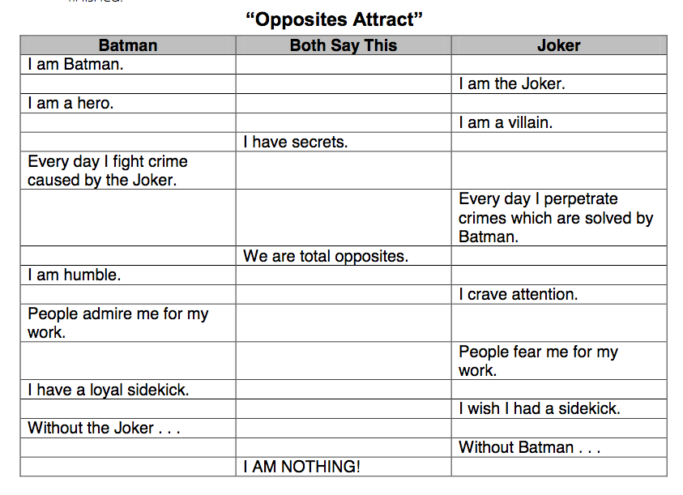

The poem can go back and forth, end together, have common lines throughout… It’s up to you! The important part is hearing the two distinct ‘voices,’ pointing out their differences and similarities.

You *may* work with someone, but you will share the same grade. Make sure both of your names are on the draft and the final (and make an extra copy so you both have one in your notebook).

Poems would look like this:

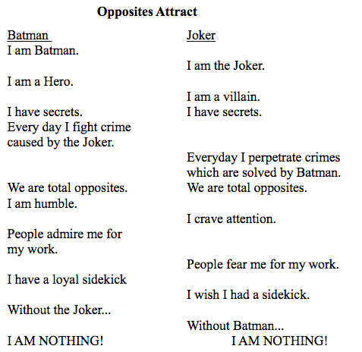

**Justice**

Atticus Finch The Mob

I want Tom to be safe. “You know what we want.”

I want the “truth to be told.” We don’t care about the truth.

I believe everyone should be treated We believe some people are worthless.

equally.

I am intelligent and just. We are uneducated and prejudiced.

I am brave enough to stand alone. We are cowards so we must stay together.

I feel love. We feel hate.

I am free from prejudice. We are prejudiced.

I believe in the justice system. We believe in our own kind of justice.

I want Tom alive. We want him dead.

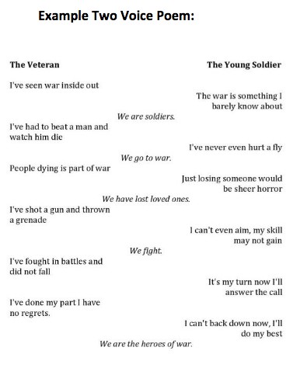

Name __________________________________________________________ Period _______

Poem in two voices

***Draft – write/type it on OWN paper without boxes***

|  |  |  |
| --- | --- | --- |
| Character/Object/Concept name: | Same | Character/Object/Concept name: |
|  |  |  |
|  |  |  |
|  |  |  |
|  |  |  |
|  |  |  |
|  |  |  |
|  |  |  |
|  |  |  |
|  |  |  |

You do not have to use ALL the boxes (but at least 5 things on each side). Use this sheet to make a final copy of your poem on a separate sheet. This paper and the final will BOTH be collected.